**ANNA UNIVERSITY REGIONAL CAMPUS COIMBATORE**

**CHATBOT DEPLOYMENT WITH IBM CLOUD**

**WATSON ASSISTANT**

**ELECTRONICS AND COMMUNICATION ENGINEERING**

SUBMITTED BY:

S. HARINI

710021106012

* **Continue building the chatbot by integrating it with messaging platforms and refining the responses.**
* **Integrate the chatbot with Facebook Messenger and Slack using respective APIs.**
* **Ensure that the conversation flows naturally and that the chatbot's responses are informative and accurate.**

**1. Define Your Chatbot's Objectives and Scope:**

Clearly outline the goals and limitations of your virtual guide. Identify the primary functions, such as providing information, answering FAQs, and maintaining a friendly conversational tone.

**2. Set Up an IBM Cloud Watson Assistant Instance:**

If you haven't already, create an instance of IBM Cloud Watson Assistant. This service will serve as the core for your chatbot's natural language understanding (NLU) capabilities.

**3. Train Watson Assistant:**

Train your Watson Assistant to understand user intents, and create a variety of dialog flows to respond to user queries effectively. You can use the Watson Assistant tool to define intents, entities, and dialog nodes for your chatbot.

**4. Implement NLU for Accurate User Intent Recognition:**

Leverage Watson Assistant's NLU capabilities to enhance your chatbot's ability to understand and respond to user queries accurately. Fine-tune the NLU models to improve intent recognition.

**5. Integrate with Messaging Platforms:**

To make your chatbot accessible on Facebook Messenger and Slack, integrate it with these platforms using their respective APIs. You will need to set up accounts and configure the chatbot to interact with these services.

**6. Develop a User-Friendly Interface:**

Create a user-friendly interface for the chatbot within the messaging platforms. Ensure that users can easily start conversations, ask questions, and receive responses.

**7. Design Conversational Flows:**

Plan out conversational flows that guide users through various interactions. This includes setting up greetings, handling FAQs, and offering assistance on different topics.

**8. Implement FAQs and Information Retrieval:**

Populate your chatbot's knowledge base with frequently asked questions and relevant information. Make sure the chatbot can retrieve and present this information to users accurately.

**9. Testing and Refinement:**

Thoroughly test your chatbot on both Facebook Messenger and Slack to ensure that it functions correctly, understands user intents, and provides accurate responses. Continuously refine the dialog flows based on user feedback.

**10. User Feedback and Learning:**

Encourage users to provide feedback, as this can help you further improve the chatbot's responses and performance over time.

**11. Maintain and Update:**

Keep the chatbot up-to-date with new information and evolving user needs. Regularly update your chatbot's responses and NLU models to stay relevant.

**12. User Education and Promotion:**

Educate users on how to interact with the chatbot effectively. Promote the availability of the virtual guide on Facebook Messenger and Slack to reach a wider audience.

**13. Monitoring and Analytics:**

Implement monitoring and analytics to track the chatbot's performance. Analyze user interactions and make data-driven improvements.

**1.click on the integration for facebook messenger**

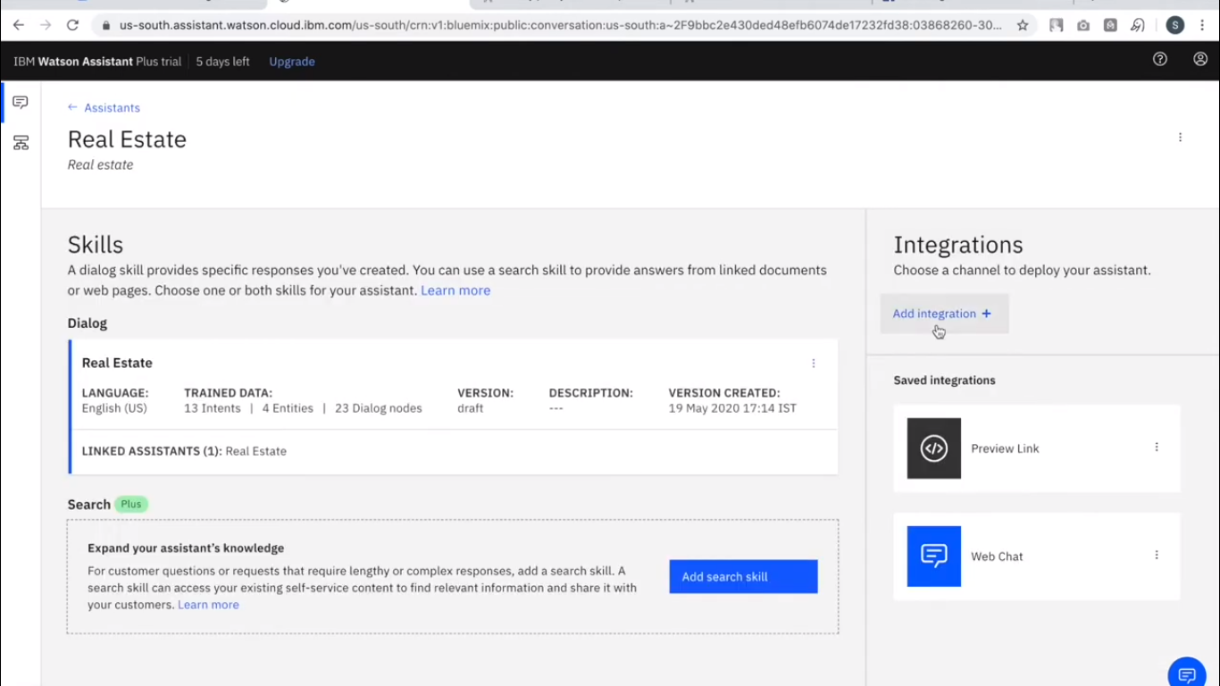

**2.click on the facebook messenger**

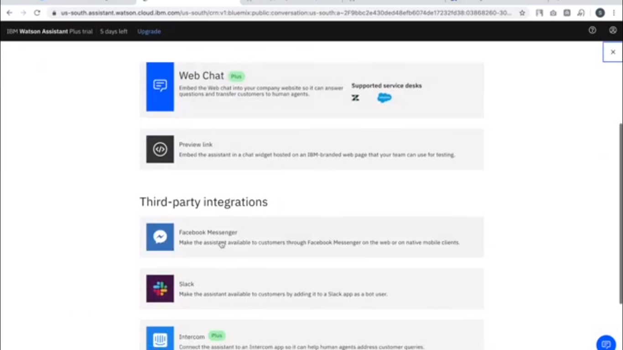

**3.put the integration name and then followed those steps**

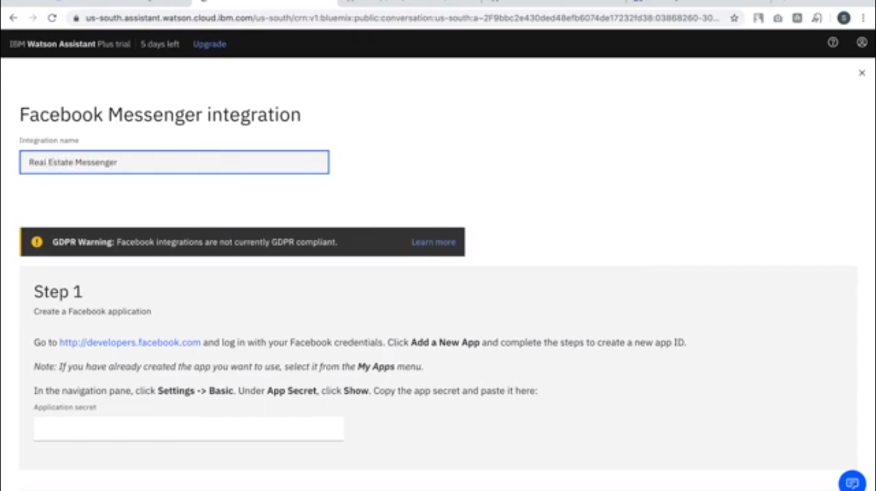

**4.create the facebook messenger app**

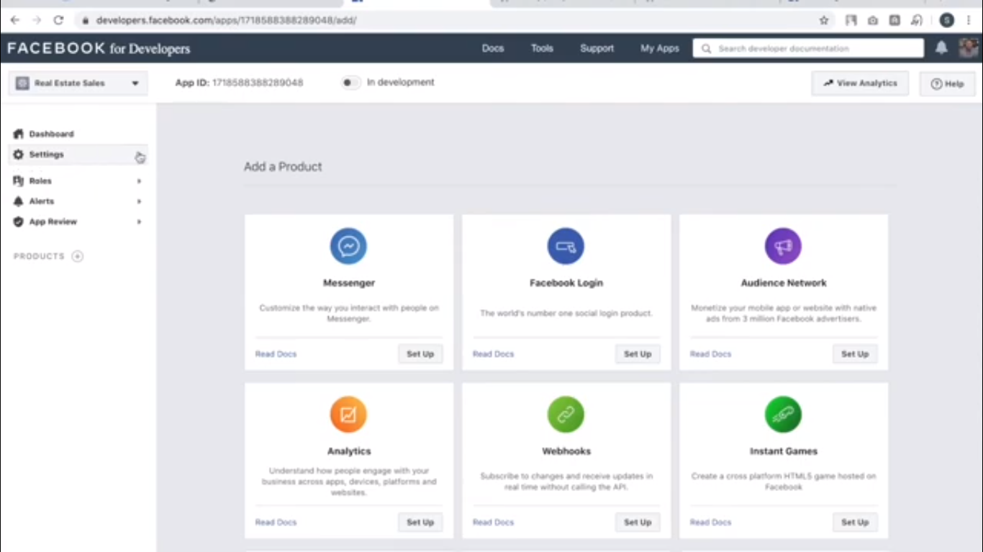

**5.open the link**

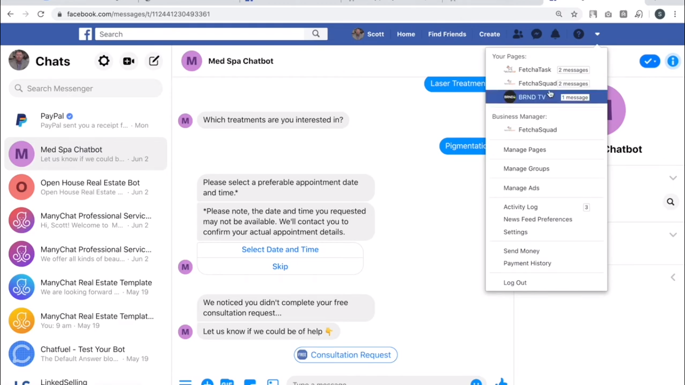

**6.test the messenger**

